Press Release: 26th Nov 2017.

Selfdrive.ae launches Electric Cars for
5 AED per hour in Dubai, UAE
Becomes first online self drive rent a car company in UAE to host Electric Cars

Dubai 26st November 2017: SelfDrive.ae announced the launch of a new segment of all electric cars (E-Cars) to its online fleet of Self Drive car rental in Dubai. In a unique initiative to promote E-Cars; SelfDrive.ae has become the first online self drive rent a car portal in the UAE to host E-Cars on the company’s “Smart Mass Mobility Technology” (SMMT) Platform.

As part of this initiative the company offers Renault Zoe All Electric Car at an introductory price of 5 AED an hour with a min billing cycle of 24 hrs with a range of 250 kms per day. These vehicles can be rented on demand and can be reserved via Selfdrive.ae web and pwa. This offer is applicable for Local Residents, International travellers, Expat and Corporates and can be reserved for a day, week or for a monthly lease. Clients renting this car would have the option to charge the car free of cost at more than 90+ Dubai Electricity and Water Authority (DEWA) locations.
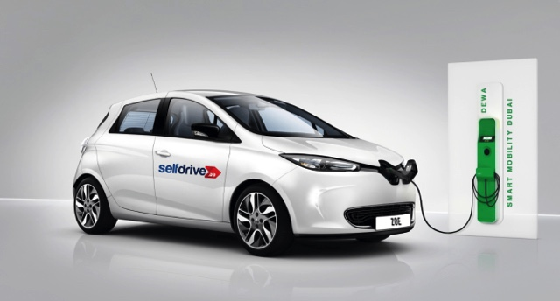

Speaking about the introduction of electric cars to its fleet, Soham Shah, Founder & Director Pinewoods Technology Services Dubai (holding company of Selfdrive.ae), said, “We are thankful to Road Transport Authority (RTA) and Dubai Electricity and Water Authority (DEWA) for collaborating to incentivize electric cars by allowing free charging across all DEWA Car charging stations, free parking and Salik Tag”. He further added, “Selfdrive.ae is proud to take first steps towards making electric cars more accessible and affordable to the masses and to create an ecosystem for people to explore the new age of mobility by introducing new avenues in smart mobility and car share technology”.

UAE is an extremely mature market with high potential for on demand Electric car rentals. With the efforts and support of the local Authority to incentivize electric Car and with the growing infrastructure of charging stations, electric cars would be the future main stream mode of transportation. SelfDrive’s Smart Mass Mobility Technology platform (SMMT) which also finds resonance with the Dubai Smart City vision of incorporating electric cars for clean energy, smart cities and self-driving cars for safer passenger transportation.

Notes to the Editors
About “SelfDrive”
The Parent Company SelfDrive.In is India’s pioneer in the self-drive car rental space. It is a 100 percent owned subsidiary of PINEWOODS SERVICE CORPORATION, incorporated in the FY 2005. Pinewoods is India’s leading Corporate Car Leasing and Car Rental Company and it is also the First Indian car rental company to kick start International operations with 2000 cars across 7 Emirates in UAE. The company has build its own proprietary platform called Smart Mass Mobility Technology (SMMT) which is future ready to host Electric Cars and Selfdriving Cars. The platform allows users to reserve Self Drive car on demand through Web/App/Phone/PWA, and choose from 75 different car models across 25 car brands, which also includes luxury brands across locations. It also offers flexibility in rental duration for the customer to select from Hourly / Daily / Weekly / Monthly / Yearly and Flexi lease Options. Operating Across 300+ sub-location with door step delivery service. Customers can enjoy unlimited free kilometers, with Zero Deposit (Excess) and drive across UAE.

E- Commerce website has helped over a million people, traveling across various cities with online spot booking, Payment Process & Confirm Reservation.

#ENDS#

